Good morning . I’m happy to be here today talking to you about my favorite city in the world,Vancouver. My name is Atinuke Abe. I’m the vice president of T and K manufacturing company. And also the head of Vancouver association of manufacturers. I have been asked to speak to you today because twenty years ago,I was making very same

Decision you are,trying to decided with city would be the best place for my business and my employees. So, today I’m going to show you four reasons you may decide to join companies likeglobal tech giants in Vancouver that we should be talking about.So first Vancouver is Seattle premier position as a center of international trade.
I know that you ship your devices all over the world.
And Seattle is ideally located equidistant from Asia and Europe by air.
And in fact, according to the US International Trade Administration,
the Seattle area is fourth in the country as an exporting hub.
And it's not just Boeing that's driving that number.
In 2012, 5,652 companies exported goods from the Seattle area.
And more than 5,000 of them were SMEs that is small or
medium size companies with fewer than 500 employees.
And as such a major transportation hub,
the Seattle area has one of the largest ports in the US.
This means that getting your products shipped out will be easy.
And that will save you time and money and
allow your company to grow much faster than anywhere else in the US.
Secondly, as you can see in this chart, the Seattle population is
significantly better educated than the average in the US, with a lot more people
with college and advanced degrees as the blue bars in this chart show you.
What does that mean for your business?
It means that you'll have a ready-made, top-notch workforce.
When you need to hire employees, you'll have the best and
brightest in the US to choose from.
And it also means excellent schools and availability of higher education for
the families of your employees.
This should help you retain your employees and leadership team.
And as we know, a happy family is a happy employee.
And speaking of happy employees, my third point is the quality of life in this area.
With breath-taking scenery, beautiful lakes,mountains,
islands, and rivers, Seattle is an outdoor playground.
Seriously your employees will be able to have a quality of life that is
unmatched in the US.
Whether they're biking, skiing, hiking, fishing, or just walking down the beach.
Your employees will have access to recreational activities outside of work
that would greatly contribute to their quality of life.
Now, one thing I know you maybe worried about is Seattle's
reputations as a rainy city.
And I was worried about that same thing.
So I was really surprised to find out that Seattle is
not even in the top ten rainiest cities in the US.
In fact it isn't even in the top 25,
that's right according to the National Weather Service,
Seattle is actually ranked number 44 in amount of rainfall.
Now it is true we have a lot of days when we get some rainfall but as you can see
from the green bars on this chart, most of the rainfall is in the winter months.
And take a look at that red line that shows our average temperatures
between 40 and 65 degrees.
It's ideal isn't it?
To recap, why Seattle?
Well for all of these reasons the Seattle area is a center for international trade,
there's a highly educated workforce and we have an unmatched quality of life.
Seattle is the very best choice for your company.
Come and join the group of excellent companies who know the very best of
the US is found in Seattle area, in the great Pacific Northwest.
Thank you.
[MUSIC]

- Salesforce. Salesforce Vancouver office (Salesforce) ...
- Disney. Industrial Light & Magic Vancouver office (Facebook) ...
- Samsung. Samsung's R&D office on Great Northern Way in Vancouver (Samsung Canada) ...
- SAP. ...
- Sony. ...
- Oracle Corporation. ...
- Mastercard. ...
- Activision.
Vancouver area.
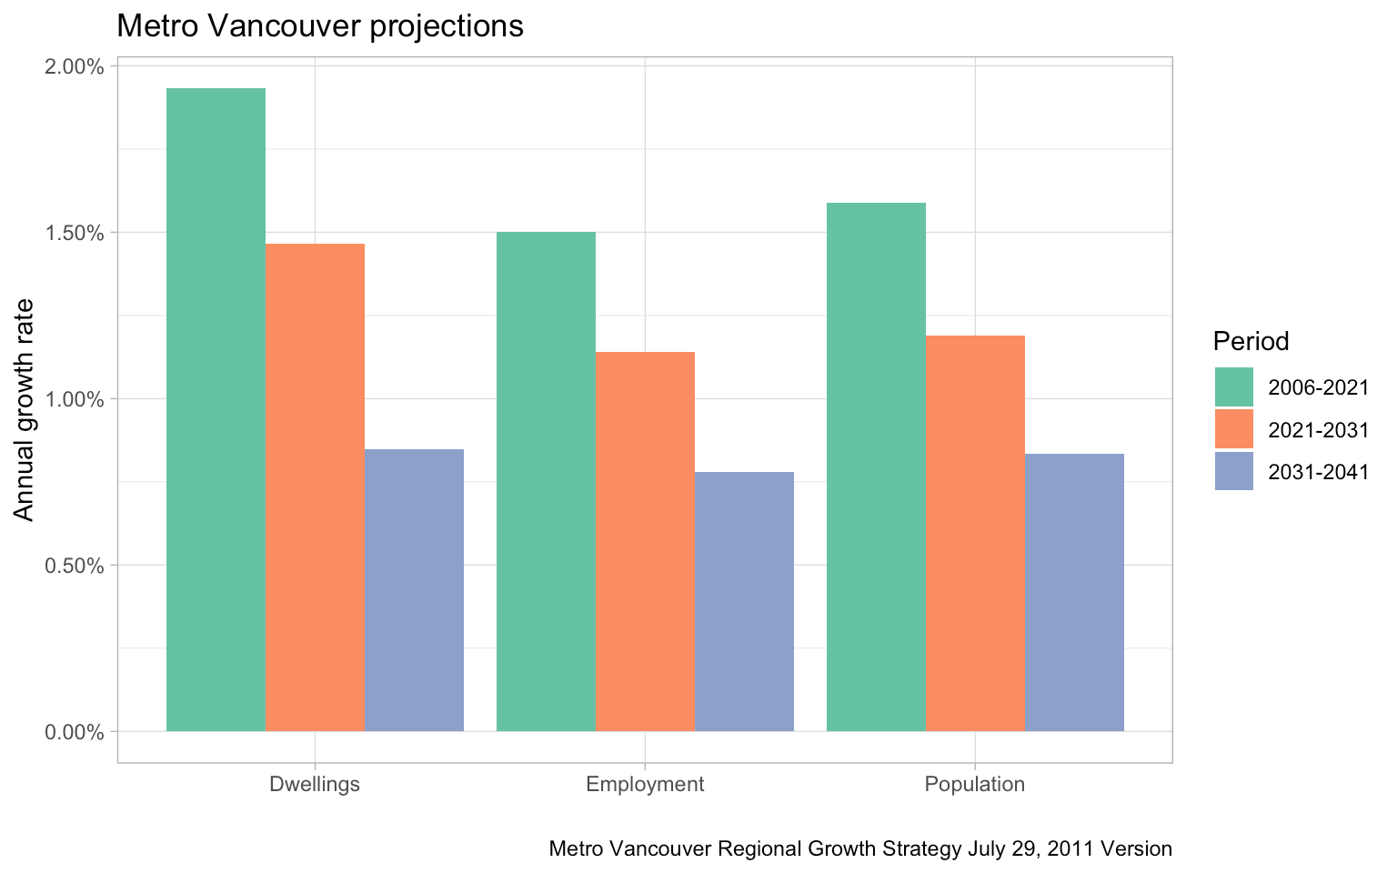

Vancouver area.

City of Vancouver
Why Settle?
The Port of Vancouver is Canada's largest port, and the most diversified port in North America.
Vancouver is famous for its fresh, local seafood, especially its salmon. Pacific Northwest salmon—including BC salmon—is shipped to every part of the world, but it's best when you can enjoy it here, fresh off the boat. Local halibut, Canadian sablefish, and BC Spot Prawns are also deliciously popular in Vancouver.

Top sights in Vancouver
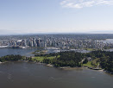  Stanley Park  Sprawling urban park with scenic seawall |   Capilano Suspension Bridge  Landmark bridge perched in the treetops | 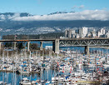  Granville Island  Artistic hub with a vibrant market |   Gastown  Steam Clock, souvenirs & trendy eateries

Its Liveability

Julius Reque/Getty Images
Vancouver is so famous for being one of the world's "most livable cities" that it's regularly cited as one of the top examples whenever "liveable" cities are discussed. Vancouver came in at number five on Mercer's Top 10 Cities list in 2016 and number three on the Economist's Global Liveability Ranking in 2015, but it's been on everyone's top 10 lists for over a decade.

03 of 10

Stanley Park

Tourism Vancouver/Albert Normandin

Good morning . I’m happy to be here today talking to you about my favorite city in the world,Vancouver. My name is Atinuke Abe. I’m the vice president of T and K manufacturing company. And also the head of Vancouver association of manufacturers. I have been asked to speak to you today because twenty years ago,I was making very same

Decision you are,trying to decided with city would be the best place for my business and my employees. So, today I’m going to show you four reasons you may decide to join companies likeglobal tech giants in Vancouver that we should be talking about.So first Vancouver is Seattle premier position as a center of international trade.
I know that you ship your devices all over the world.
And Seattle is ideally located equidistant from Asia and Europe by air.
And in fact, according to the US International Trade Administration,
the Seattle area is fourth in the country as an exporting hub.
And it's not just Boeing that's driving that number.
In 2012, 5,652 companies exported goods from the Seattle area.
And more than 5,000 of them were SMEs that is small or
medium size companies with fewer than 500 employees.
And as such a major transportation hub,
the Seattle area has one of the largest ports in the US.
This means that getting your products shipped out will be easy.
And that will save you time and money and
allow your company to grow much faster than anywhere else in the US.
Secondly, as you can see in this chart, the Seattle population is
significantly better educated than the average in the US, with a lot more people
with college and advanced degrees as the blue bars in this chart show you.
What does that mean for your business?
It means that you'll have a ready-made, top-notch workforce.
When you need to hire employees, you'll have the best and
brightest in the US to choose from.
And it also means excellent schools and availability of higher education for
the families of your employees.
This should help you retain your employees and leadership team.
And as we know, a happy family is a happy employee.
And speaking of happy employees, my third point is the quality of life in this area.
With breath-taking scenery, beautiful lakes,mountains,
islands, and rivers, Seattle is an outdoor playground.
Seriously your employees will be able to have a quality of life that is
unmatched in the US.
Whether they're biking, skiing, hiking, fishing, or just walking down the beach.
Your employees will have access to recreational activities outside of work
that would greatly contribute to their quality of life.
Now, one thing I know you maybe worried about is Seattle's
reputations as a rainy city.
And I was worried about that same thing.
So I was really surprised to find out that Seattle is
not even in the top ten rainiest cities in the US.
In fact it isn't even in the top 25,
that's right according to the National Weather Service,
Seattle is actually ranked number 44 in amount of rainfall.
Now it is true we have a lot of days when we get some rainfall but as you can see
from the green bars on this chart, most of the rainfall is in the winter months.
And take a look at that red line that shows our average temperatures
between 40 and 65 degrees.
It's ideal isn't it?
To recap, why Seattle?
Well for all of these reasons the Seattle area is a center for international trade,
there's a highly educated workforce and we have an unmatched quality of life.
Seattle is the very best choice for your company.
Come and join the group of excellent companies who know the very best of
the US is found in Seattle area, in the great Pacific Northwest.
Thank you.
[MUSIC]

- Salesforce. Salesforce Vancouver office (Salesforce) ...
- Disney. Industrial Light & Magic Vancouver office (Facebook) ...
- Samsung. Samsung's R&D office on Great Northern Way in Vancouver (Samsung Canada) ...
- SAP. ...
- Sony. ...
- Oracle Corporation. ...
- Mastercard. ...
- Activision.
Vancouver area.

